Dear sir ,

Find below final pension withdrawal process:

The process flow is as below:
a. Login to Member Interface of Unified Portal work
(https://unifiedportalmem.epfindia.gov.in/memberinterface) +912279651876
b. Go to Online Services>>Claim (Form-31,19,10C & 10D) Mobile
c. Enter your Bank Account and verify +919372172800
d. Click on “Proceed for Online Claim”
e. Select from10C the drop down
f. Upload scanned copy of cheque and enter your address
g. Click on “Get Aadhaar OTP”
h. Enter the OTP received on Aadhaar linked mobile.
i. Claim is submitted.

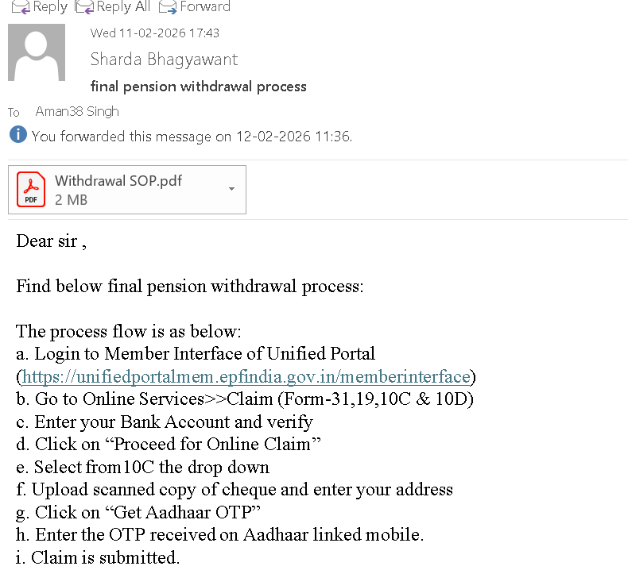

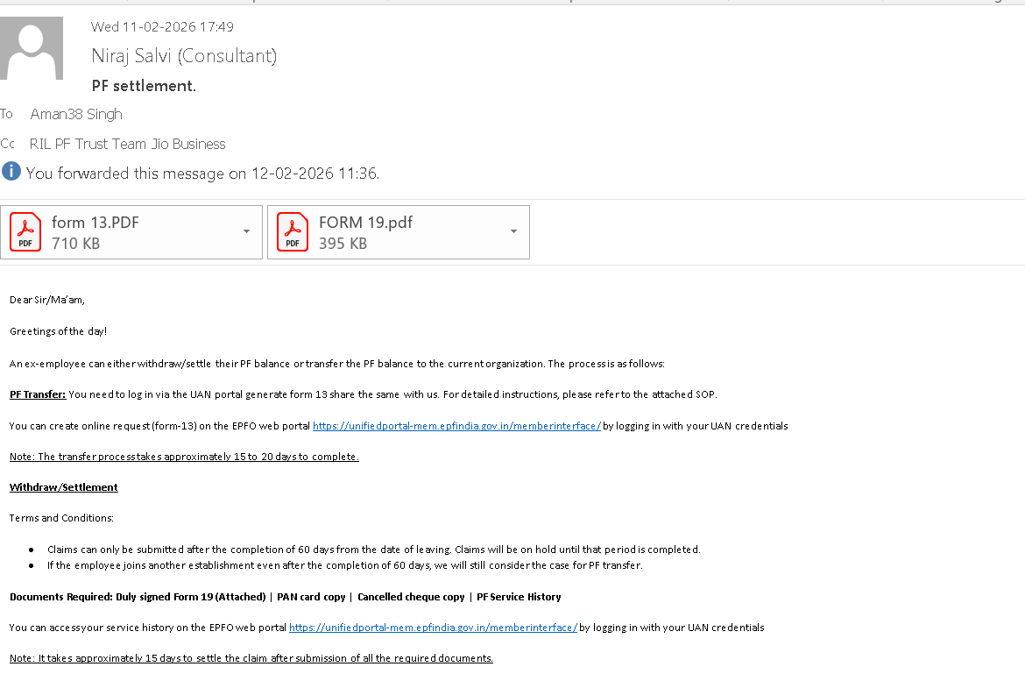

Dear Sir/Ma’am,

Greetings of the day!

An ex-employee can either withdraw/settle their PF balance or transfer the PF balance to the current organization. The process is as follows:

PF Transfer: You need to log in via the UAN portal generate form 13 share the same with us. For detailed instructions, please refer to the attached SOP.

You can create online request (form-13) on the EPFO web portal https://unifiedportal-mem.epfindia.gov.in/memberinterface/ by logging in with your UAN credentials

Note: The transfer process takes approximately 15 to 20 days to complete.

Withdraw/Settlement

Terms and Conditions:

- Claims can only be submitted after the completion of 60 days from the date of leaving. Claims will be on hold until that period is completed.
- If the employee joins another establishment even after the completion of 60 days, we will still consider the case for PF transfer.

Documents Required: Duly signed Form 19 (Attached) | PAN card copy | Cancelled cheque copy | PF Service History

You can access your service history on the EPFO web portal https://unifiedportal-mem.epfindia.gov.in/memberinterface/ by logging in with your UAN credentials

Note: It takes approximately 15 days to settle the claim after submission of all the required documents.

Regards,
Niraj Salvi

Mobile:

+918898939892

